Problem Statement
You are part of a team which is involved in developing an E-Commerce Website.
The E-commerce website manages its data in the Database..

- You are required to create tables for supplier,customer,category,product,supplier_pricing,order,rating to store the data for the E-commerce with the schema definition given below.
- You are required to develop SQL based programs (Queries) to facilitate the Admin team of the E-Commerce company to retrieve the data in summarized format - The Data Retrieval needs are described below.

Table:supplier
Columns:
SUPP_ID | INT PK
SUPP_NAME | varchar(50) NOT NULL
SUPP_CITY | varchar(50)  NOT NULL
SUPP_PHONE | varchar(50) NOT NULL

Table:customer
Columns:
CUS_ID | INT PK
CUS_NAME | VARCHAR(20) NOT NULL
CUS_PHONE | VARCHAR(10) NOT NULL
CUS_CITY | VARCHAR(30) NOT NULL
CUS_GENDER | CHAR

Table:category
Columns:
CAT_ID | INT PK
CAT_NAME | VARCHAR(20) NOT NULL

Table:product
Columns:
PRO_ID | INT PK
PRO_NAME | VARCHAR(20) NOT NULL DEFAULT "Dummy"
PRO_DESC | VARCHAR(60)
CAT_ID | INT FK

Table:supplier_pricing
Columns:
PRICING_ID | INT PK
PRO_ID | INT FK
SUPP_ID | INT FK
SUPP_PRICE | INT DEFAULT 0

Table:order
Columns:
ORD_ID | INT PK
ORD_AMOUNT | INT  NOT NULL
ORD_DATE | DATE  NOT NULL
CUS_ID | INT FK
PRICING_ID | INT FK

Table:rating
Columns: (Rating provided in this table is common for product and supplier)
RAT_ID | INT PK
ORD_ID | INT FK
RAT_RATSTARS | INT  NOT NULL

- Insert the following data in the table created above

Supplier Table-

SUPP_ID SUPP_NAME SUPP_CITY SUPP_PHONE
1 Rajesh Retails Delhi 1234567890
2 Appario Ltd. Mumbai 2589631470
3 Knome products Banglore 9785462315
4 Bansal Retails Kochi 8975463285
5 Mittal Ltd. Lucknow 7898456532

Customer Table-

CUS_ID CUS_NAME CUS_PHONE CUS_CITY CUS_GENDER
1 AAKASH 9999999999 DELHI M
2 AMAN 9785463215 NOIDA M
3 NEHA 9999999999 MUMBAI F
4 MEGHA 9994562399 KOLKATA F
5 PULKIT 7895999999 LUCKNOW M

Category Table-

CAT_ID CAT_NAME
1 BOOKS
2 GAMES
3 GROCERIES
4 ELECTRONICS
5 CLOTHES

Product Table-

PRO_ID PRO_NAME PRO_DESC CAT_ID
1 GTA V Windows 7 and above with i5 processor and 8GB RAM 2
2 TSHIRT SIZE-L with Black, Blue and White variations 5
3 ROG LAPTOP Windows 10 with 15inch screen, i7 processor, 1TB SSD 4
4 OATS Highly Nutritious from Nestle 3
5 HARRY POTTER Best Collection of all time by J.K Rowling 1
6 MILK 1L Toned MIlk 3
7 Boat Earphones 1.5Meter long Dolby Atmos 4
8 Jeans Stretchable Denim Jeans with various sizes and color 5
9 Project IGI compatible with windows 7 and above 2
10 Hoodie Black GUCCI for 13 yrs and above 5
11 Rich Dad Poor Dad Written by RObert Kiyosaki 1
12 Train Your Brain By Shireen Stephen 1

Supplier_pricing Table-

PRICING_ID PRO_ID SUPP_ID SUPP_PRICE

1 1 2 1500
2 3 5 30000
3 5 1 3000
4 2 3 2500
5 4 1 1000
6 12 2 780
7 12 4 789
8 3 1 31000
9 1 5 1450
10 4 2 999
11 7 3 549
12 7 4 529
13 6 2 105
14 6 1 99
15 2 5 2999
16 5 2 2999

Order Table-

ORD_ID ORD_AMOUNT ORD_DATE CUS_ID PRICING_ID
101 1500 2021-10-06 2 1
102 1000 2021-10-12 3 5
103 30000 2021-09-16 5 2
104 1500 2021-10-05 1 1
105 3000 2021-08-16 4 3
106 1450 2021-08-18 1 9
107 789 2021-09-01 3 7
108 780 2021-09-07 5 6
109 3000 2021-00-10 5 3
110 2500 2021-09-10 2 4
111 1000 2021-09-15 4 5
112 789 2021-09-16 4 7
113 31000 2021-09-16 1 8
114 1000 2021-09-16 3 5
115 3000 2021-09-16 5 3
116 99 2021-09-17 2 14

Rating table-
RAT_ID ORD_ID RAT_RATSTARS
1 101 4
2 102 3
3 103 1
4 104 2
5 105 4
6 106 3
7 107 4
8 108 4
9 109 3
10 110 5
11 111 3
12 112 4
13 113 2
14 114 1
15 115 1
16 116 0

Queries →

Write queries for the following:

- Display the total number of customers based on gender who have placed individual orders of worth at least Rs.3000.
- Display all the orders along with product name ordered by a customer having Customer_Id=2
- Display the Supplier details who can supply more than one product.
- Find the least expensive product from each category and print the table with category id, name, product name and price of the product
- Display the Id and Name of the Product ordered after “2021-10-05”.
- Display customer name and gender whose names start or end with character 'A'.
- Create a stored procedure to display supplier id, name, Rating(Average rating of all the products sold by every customer) and Type_of_Service. For Type_of_Service, If rating =5, print “Excellent Service”,If rating >4 print “Good Service”, If rating >2 print “Average Service” else print “Poor Service”. Note that there should be one rating per supplier.

Schema:

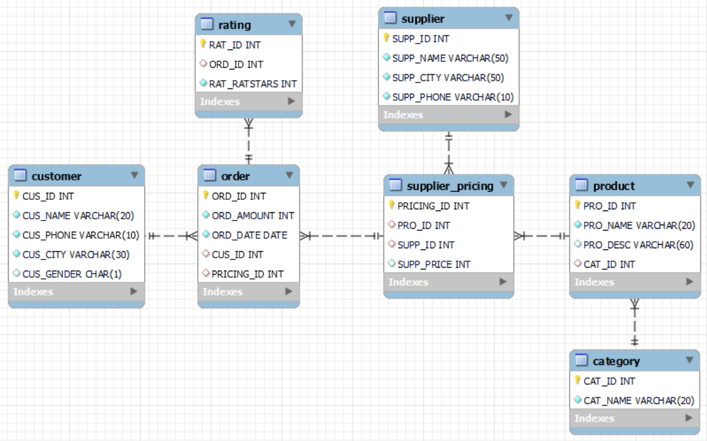

Learning Objectives:
After completing this project,
Learner will be able to Understand the Database Schemas for a Business Org and will be able to design the database and
corresponding tables that are needed for an e-Commerce WebSite.

Also Learner will be able to design SQL queries to retrieve data involving the following features of MySQL:
- Select Queries (with logical & comparison operators)
- Group By / Order By / Having Clauses
- Joins
- Sub Queries
- Procedures (Creating & Executing )
- Use case construct in a procedure.

